Setting up EndNote sync for collaboration (Windows & Mac)

Sync to a new EndNote Online account
EndNote 20 gives you the ability to sync your Endnote library across two or more computers via EndNote Online: http://www.myendnoteweb.com/. Once you have a group in EndNote Online, you can share it with fellow researchers.
Note: You can sync one library with up to 50,000 references, 5,000 groups and unlimited attachments. You can only link one library to an EndNote Online account.
- Open your library in EndNote 20.
- Go to Edit > Preferences > Sync.
Note: If using a Mac go to EndNote 20 > Preferences > Sync.
- Click on Enable Sync button.
- If you don’t already have an EndNote Online account, click on the Sign Up button.
- Enter your email address twice - you do not have to use your RMIT email account. This email address will become your login.
- Click Submit.
- Fill in all of the required fields that have a red *
- Click I agree.
- Your registration is complete. Click Done.
- The Sync process will authorise your new account and automatically add any references to your EndNote 20 library.
- If you have references in the library, you will be asked to make a compressed backup. Follow the instructions to do so.
The first time you sync it may take a while for the sync process to complete (especially if you have many references with full text). Note that future syncing will be quicker.
EndNote 20 and EndNote Online will now sync automatically.
Want to check how much space you have left on EndNote Online? Click Sync Status on the top left of screen in EndNote 20.

Sync to an existing EndNote Online account

- Open your library in EndNote 20.
- Go to Edit > Preferences > Sync.
Note: If using a Mac go to EndNote 20 > Preferences > Sync.
- Type your existing EndNote Online login and password into the EndNote Account Credentials fields.
- Click OK.
- You may be asked to register the computer for your EndNote Online account. Fill in all of the required fields that have a red *
- Click I agree.
- Your registration is complete. Click Sync.
- Click OK to save the settings.
Want to check how much space you have left on EndNote Online? Click Sync Status on the top left of screen in EndNote 20.

Sync an existing account to a second computer
- If you have already created and synced an EndNote library on a first computer, make sure to note the name of the library.
- Open EndNote 20 on a second computer (Windows or Mac).
- Click File > New.
- Create a new library with the same name as the original synced library.
- Go to Edit > Preferences > Sync.
Note: If using a Mac go to EndNote 20 > Preferences > Sync.
- Type your existing EndNote Online login and password into the EndNote Account Credentials fields.
- Click OK.
The first time you sync it may take a while for the sync process to complete (especially if you have many references with full text). Note that future syncing will be quicker.
The synced library's references, attachments and groups will be added to the library on your second machine.
Your computers will now sync to EndNote Online and update automatically.
Note: Remember to regularly back up your Word documents.

Sharing a library via EndNote 20

It's very easy to share an EndNote library or a Group(s) with up to 100 colleagues. The full record, including attached full text or images will also be shared.
- Sync your EndNote library (see above steps).
- If you wish to share your entire EndNote 20 library, click File > Share.
- Or, if you only want to share a specific Group(s): from the GROUPS section to the left of screen, select a Group and click the Share this group icon on the toolbar
- After selecting either option, a Sharing screen will appear. Enter each email address, separated by commas.
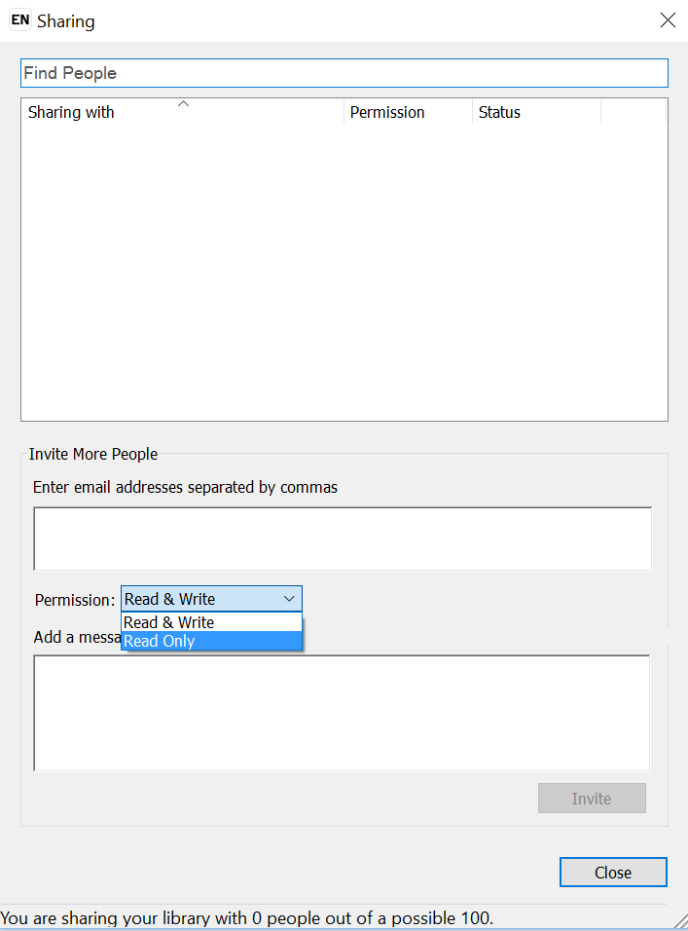
- Change the Permission setting, so that recipients have either Read & Write or Read Only access.
- Type a message in the Add a message box (if applicable).
- When finished, click Invite.
Your colleagues will receive an email asking them to accept your invitation. They will only be able to do so if they are using a more recent version of EndNote e.g. X7.1 or later.
Note: Older versions of EndNote (prior to X7.1) do NOT have share functionality.
Once your colleagues click Accept they will be redirected to their EndNote Online account, where they need to login and Accept.

Managing Shared Groups

When you sync an existing EndNote Online account with EndNote 20, you may duplicate group names or references, or introduce new groups into the EndNote 20 library.
Any new EndNote Online groups are automatically added to your MY GROUPS list.
When new groups are added, it’s recommended that you check for any duplicates that may now appear in your library:
- Select Library > Find Duplicates to identify and remove any duplicated references.
Note: Before deleting duplicates, you will need to check your Word document to verify what duplicate number(s) are listed so you don’t delete the wrong reference.
- Once any changes have been made to your shared library, you can then refresh the sync status. To do this select Sync Status from the top left of screen and click on the Sync now button.
Note: You should also refresh your EndNote Online library to reflect the new changes.
- Please remember to regularly back up your Word document, and also your EndNote library by using the File > Compress Library (.enlx) option.

